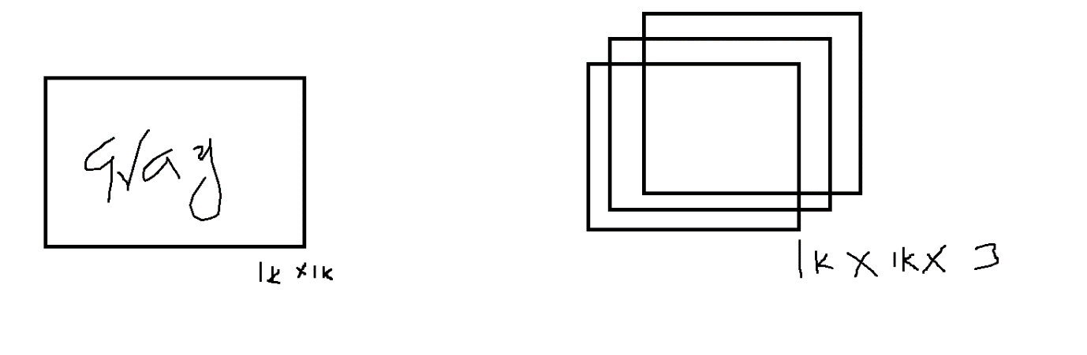

<https://medium.com/@gokcenazakyol/what-is-image-enhancement-image-processing-3-32a813087e0a>

<https://sbme-tutorials.github.io/2018/cv/notes/4_week4.html#sobel-operator>

|  |  |  |  |  |
| --- | --- | --- | --- | --- |
| 1 | 1 | 1 | 0 | 0 |
| 0 | 1 | 1 | 1 | 0 |
| 0 | 0 | 1 | 1 | 1 |
| 0 | 0 | 1 | 1 | 0 |
| 0 | 1 | 1 | 0 | 0 |

|  |  |  |
| --- | --- | --- |
| 1 | 0 | 1 |
| 0 | 1 | 0 |
| 1 | 0 | 1 |

|  |  |  |  |  |
| --- | --- | --- | --- | --- |
| 1 (1) | 1  (0) | 1  (1) | 0 | 0 |
| 0  (0) | 1  (1) | 1  (0) | 1 | 0 |
| 0  (1) | 0  (0) | 1  (1) | 1 | 1 |
| 0 | 0 | 1 | 1 | 0 |
| 0 | 1 | 1 | 0 | 0 |

1*1 + 1*0 + 1*1 + 0*0 + 1*1 + 1*0 + 0*1 + 0*0 + 1*1=4

|  |  |  |  |  |
| --- | --- | --- | --- | --- |
| 1 | 1  (1) | 1  (0) | 0  (1) | 0 |
| 0 | 1  (0) | 1  (1) | 1  (0) | 0 |
| 0 | 0  (1) | 1  (0) | 1  (1) | 1 |
| 0 | 0 | 1 | 1 | 0 |
| 0 | 1 | 1 | 0 | 0 |

= 3

|  |  |  |  |  |
| --- | --- | --- | --- | --- |
| 1 | 1 | 1  (1) | 0  (0) | 0  (1) |
| 0 | 1 | 1  (0) | 1  (1) | 0  (0) |
| 0 | 0 | 1  (1) | 1  (0) | 1  (1) |
| 0 | 0 | 1 | 1 | 0 |
| 0 | 1 | 1 | 0 | 0 |

=4

|  |  |  |  |  |
| --- | --- | --- | --- | --- |
| 1 | 1 | 1 | 0 | 0 |
| 0  (1) | 1  (0) | 1  (1) | 1 | 0 |
| 0  (0) | 0  (1) | 1  (0) | 1 | 1 |
| 0  (1) | 0  (0) | 1  (1) | 1 | 0 |
| 0 | 1 | 1 | 0 | 0 |

2,4,3

First slide to right : 4,3,4

Second time slide to right= 2,4,3

Third time slide to right = 2,3,4

New Image:

|  |  |  |
| --- | --- | --- |
| 4 | 3 | 4 |
| 2 | 4 | 3 |
| 2 | 3 | 4 |

$$Irrespective image size, in cnn the input weights depends only on filter size$$

$$Original image=5*5 Filter size=3*3 feature map=3*3$$

$$Original image=6*6 Filter size=3*3 feature map=4*4$$

$$Original image=7*7 Filter size=3*3 feature map=5*5$$

$$Original image=N*N Filter size=F*F feature map=(N-F+1)*(N-F+1)$$

$$Original image=5*5*3 Filter size=3*3*3 feature map=3*3$$

$$Original image=6*6*3 Filter size=3*3*3 feature map=4*4$$

$$Original image=7*7*3 Filter size=3*3*3 feature map=5*5$$

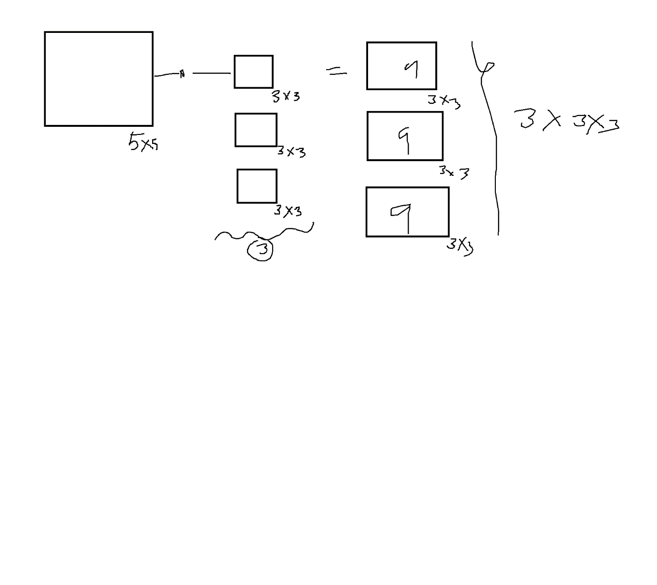

$$Original image=6*6 Filter size=2*2 feature map=5*5$$

$$Original image=6*6 Filter size=3*3 feature map=4*4$$

$$Original image=6*6 Filter size=4*4 feature map=3*3$$

$$Original image=6*6 Filter size=5*5 feature map=2*2$$

$$Draw back:$$

$$As fiter size increases , the result of feature map size decrease$$

$$which means result image has less pixel values,$$

$$training on less values always not give the best performance$$

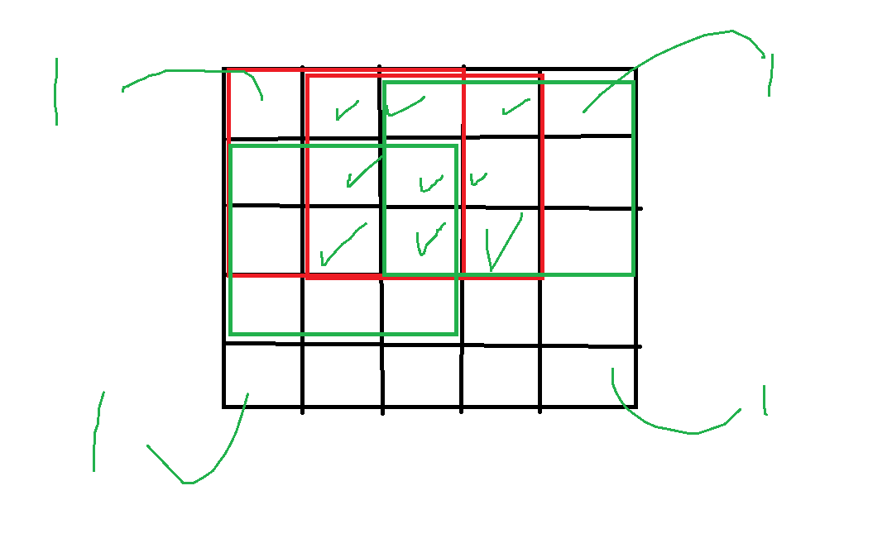

$$Convolving filter with edges of image happens one time only, we might loss$$

$$Important patterns$$

$$The result image going to shrink as filter size incresaes, and the edges informant not$$

$$capturing properly$$

$$Padding:$$

$$To avoid the draw back will add an extra layer is called padding$$

$$will add zeros on extra layer$$

$$Original image Convolve with Filter====Feature map$$

$$In this process we can add padding$$

$$Striding$$

$$In order to convolve speed the filter sliding will incrase by 1$$

$$Instead of multiplying sliding window by one, it will skip one step$$

$$stride \left(s\right)=2$$

$$In this process we can add stride$$

$$In this process we can add multiple filter$$

$$Goal: We need to minimize the image size with out lose the information$$

$when we are multiplying original image with filter , we are reducing our image size$

$when we are adding stride more again we are reducing our image size$

$we can reduce our image further by applying Pooling method$

$$After we get the feature map$$

$$Pooling$$

$$From the feature map we can extract an important feature , this is called pooling$$

$Max pooling$

$Average pooling$

$$Assume that your feature map size is 8*8$$

$$Pool size is 2*2$$

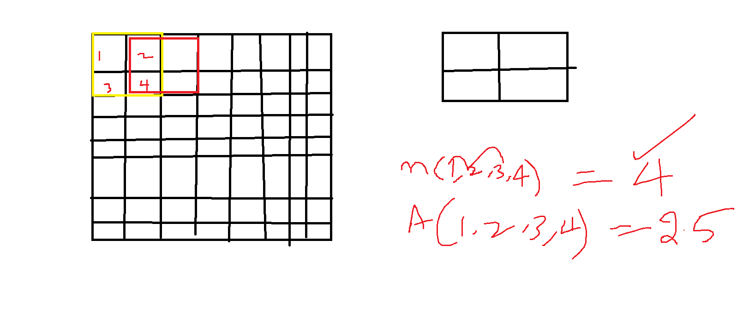

$$Original image convolve withfilter===Feature map$$

$$In this process Padding stride no of filters$$

$$Pooling on Feature map==== > Final Feture map$$

$$This process is called 1Conv layer$$

$$Final feature map=Image 2 * Filter$$

$$In this process Padding stride no of filters$$

$$Poolin on Feature map==== > Final Feture map$$

$$2Conv layer$$

-------- Repeat

$$Finally will get one image ======Flatten+Hidden layer + Output layer$$

$$Last calss we have seen image size 28*28$$

$$Model .add \left(Flatten\right)$$

$$Model.add\left(Dense\right)$$

$$Model.add(Dense)$$

$$Con1 layer$$

$$Conv2 layer$$

$$Conv3 layer$$

$$Flatten$$

$$Hidden$$

$$Output$$